# Custom Classes

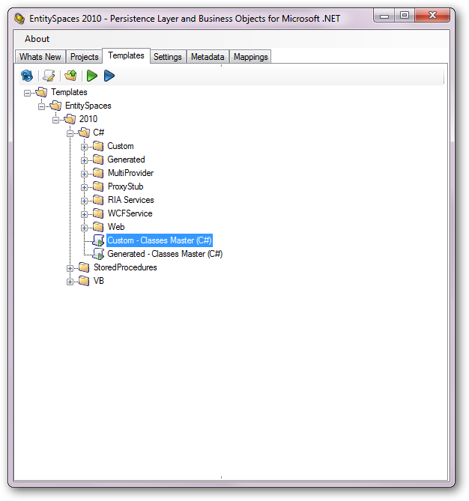

# Custom Classes – Basic Information Tab

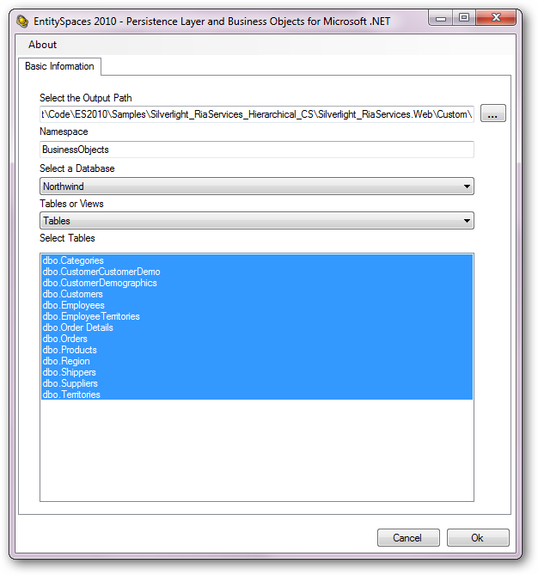

# Generated Classes

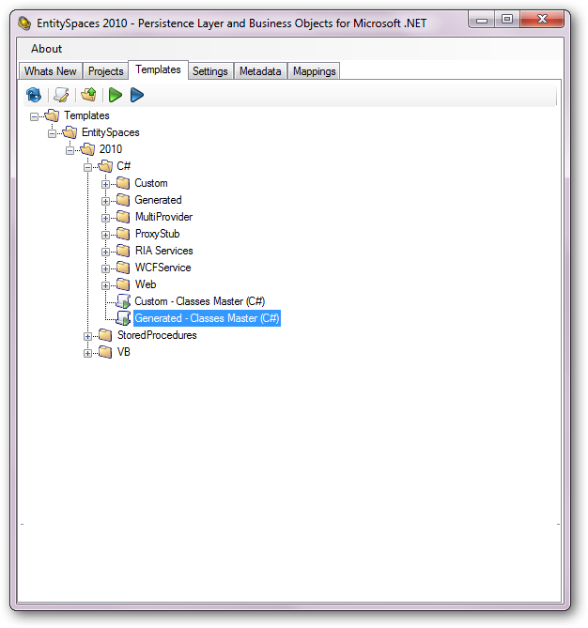

# Generated Master – Basic Information Tab

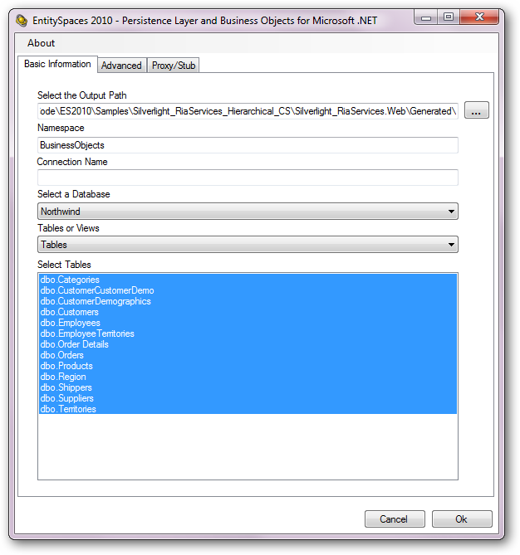

# Generated Master – Advanced Tab

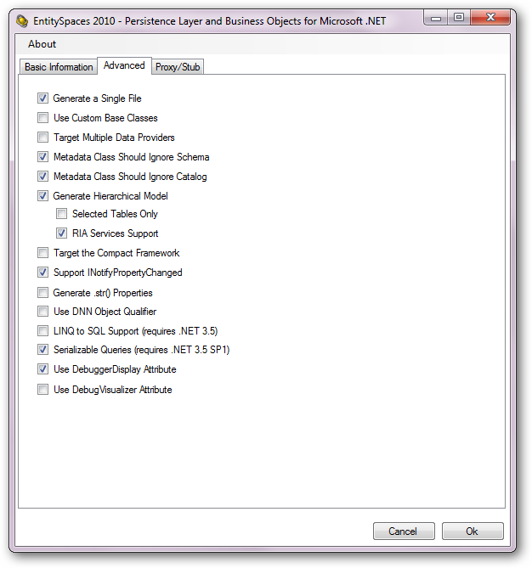

# RIA Shared Classes

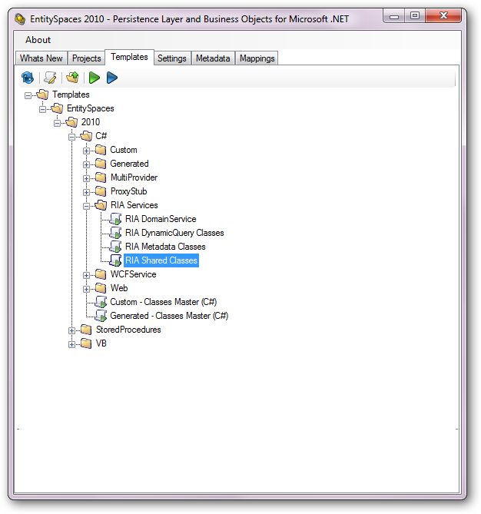

# RIA Shared Classes – Shared Class Tab

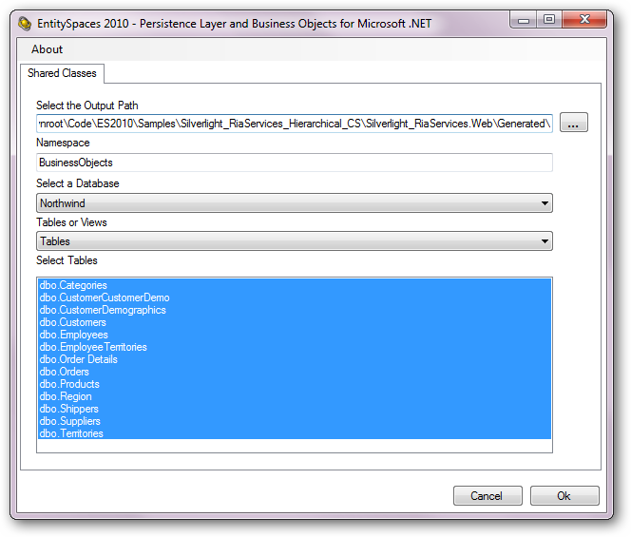

These go in the Generated folder along with your Generated Business objects.

# RIA Metadata Classes

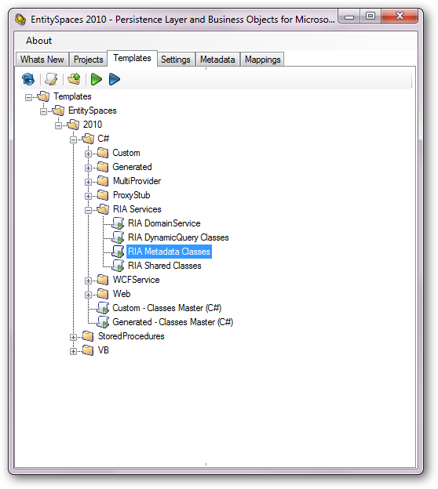

# RIA Metadata Classes – Metadata Classes Tab

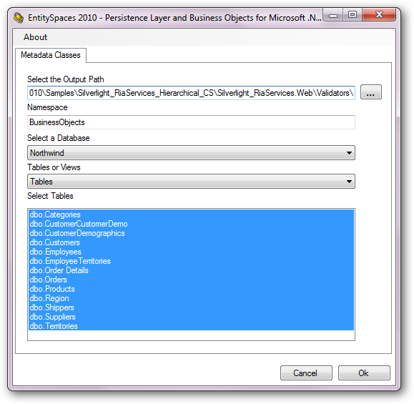

## RIA Domain Service

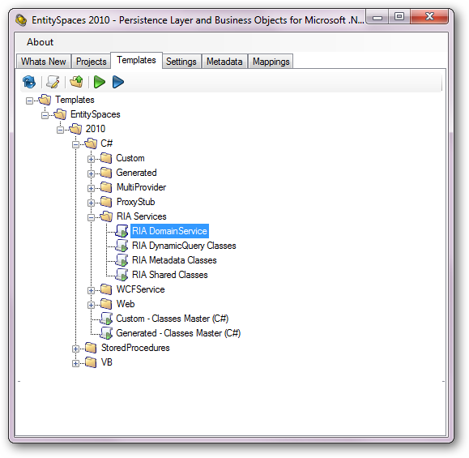

## RIA Domain Service – Domain Service Tab

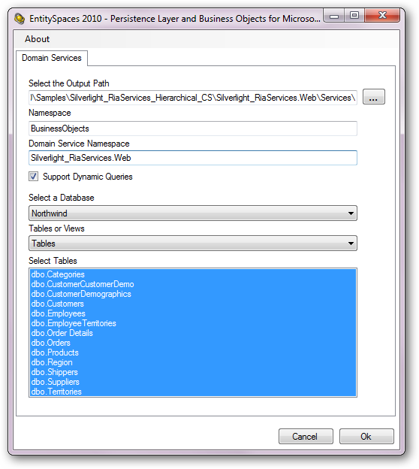

# RIA DynamicQuery Classes

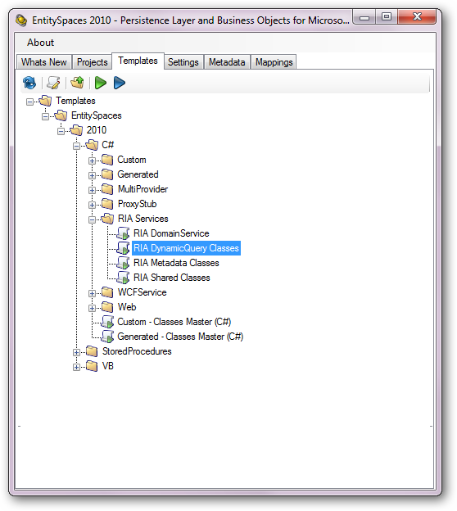

# RIA DynamicQuery Classes – RIA Dynamic Query Classes Tab

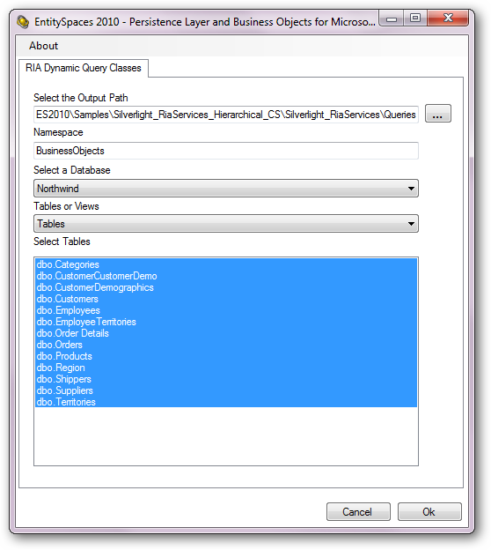

Notice that these go in your Silverlight Application not the Web Application.